Understanding
Spiritual Abuse –
Creating Healthy
Cultures

Exercise Pack

Discussion

- Who are the perpetrators of spiritual abuse?

- Are there particular expressions of church where spiritual abuse is more likely to occur? If so, why?
Write your own notes here:

Key Characteristics of Spiritual Abuse

The whole experience is one of coercion and control and there are some key features which can act as indicators.
Use of scripture to coerce and control

Teaching and challenging through scripture is part of the Christian journey. However, it would become concerning if scripture was being used to coerce and control rather than guide. It should be used for the development and nurture of the person receiving the teaching/scripture, rather than to fulfil the agenda of the person sharing. There are key biblical messages such as unity and submission which can be misused to coerce and control.
Enforced Accountability
Accountability can be a positive element of the Christian life. However, where people feel forced into being accountable this would give rise to concern. Obviously, there may be times when accountability is essential (for example where there is a safeguarding agreement in place). However, generally individuals should be able to exercise consent and set boundaries around accountability.
Manipulation and Exploitation
Manipulation and exploitation are hallmarks of spiritual abuse. Often people feel under pressure in a variety of ways and feel that they must conform to increasing expectations of others. These requests often involve excessive service, presence at all meetings etc. Conformity can be suggested to be a measure of how much an individual loves God or how healthy their spiritual life is. In a coercive controlling culture often only service inside of Church is valued.
Censorship
Censorship is a hallmark of spiritual abuse. There are several ways communication is censored. One way is pressurising people to be silent if they disagree or raise concerns about harmful behaviour. Information is often carefully controlled ensuring a position of power for the abuser. It is often difficult to ask questions, to disagree or raise concerns without being accused of causing division or being difficult. Decision making may be censored in that it may be presented as a team decision but in reality, it is being made by one or a few individuals with everyone else expected to agree.
Requirement for Blind Obedience
There can be a requirement for blind obedience to the abuser. This obedience can be equated to the individual’s obedience and love for God. An individual can feel pressured into submitting to requests that they do not wish to. They may fear the abuser or fear what God might think of them if they don’t.
Use of ‘divine’ calling to coerce
In some cases, an individual may use their ‘divine calling’ to put pressure on others to conform or obey. There can be a suggestion that ‘God put me here and you can’t disagree with me’. It is important to note that many believe that people are called and anointed for different roles. However, it is when this calling is used to coerce and control others and where the suggestion is to disagree is almost like disagreeing with God, that there should be concern.
Exclusion and Isolation
Exclusion and isolation are used as a form of punishment either for disobedience or non-conformity. An individual might find themselves isolated within the Church. There is also external isolation sometimes where people are discouraged from mixing with other Churches or those outside of the relationship or culture.
Public Shaming and Humiliation
Some people will experience public shame to rebuke them. This can be really damaging and often leaves the individual unable to challenge back.
Discussion

- Read and consider the key characteristics of spiritual abuse?

- Can you think of an example of each?
Write your own notes here:

Discussion

- Read the first part of the case study below:
Andrew begins attending a new Church. You meet up with him for tea and he tells you that the Church is great. He says that he is really enjoying it. He tells you he had a bit of a chat a few weeks ago with the minister who rang him
after he missed a service but that he only did this because he cares.

- What, if any, are your concerns?
Write your own notes here:

- Read the second part of the case study below:
You meet Andrew again after a couple of weeks and ask him how Church is going. He says that it is still going well. He says he is a bit tired as you are expected to be at lots of meetings, but he doesn’t mind because he loves God. He tells you he is a bit worried as he is struggling to give financially to the Church. He explains that when he raised this, the minister showed him bible verses about giving and how important it was. Andrew tells you that he wants to be a good Christian and so will need to work out a way to give more.
- What if any are your concerns?
Write your own notes here:

- Read the third part of the case study below:
After Christmas you bump into Andrew in town. He asks to go for a coffee. He tells you that over the past two months he has found Church very difficult. He says that there is a lot of pressure and control. He tells you he is scared to speak out as when other people have done this, the minister has been upset with them and often spoken badly of them publicly. He also tells you that he is now aware that many people have left the Church over the past two years. He met one of them who said he couldn’t cope anymore with the pressure and never feeling like he was good enough. Andrew tells you that he also wants to leave but is afraid to, as he is not sure what God will think of him. He says the minister has told him that God will not bless him if he leaves.

- What, if any, are your concerns?

- At which point might you consider this to be spiritual abuse?
Write your own notes here:

Activity - Discussion

- Listen to the audio and consider the impacts of spiritual abuse on an individual.
Write your own notes here:

Discussion

- The diagram below illustrates some of the impacts of this experience and is based upon an analysis of stories of those who have experienced spiritual abuse.

- There are some additional factors and explanations following the diagram.

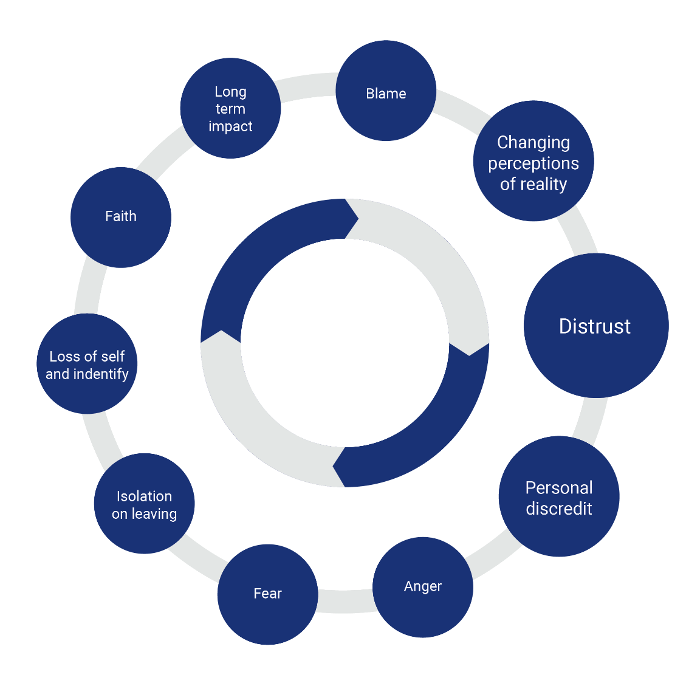

Oakley & Kinmond, 2013.

Distrust

After this experience many people find trusting others very difficult. They feel they were unsafe in what should have been a safe place. So now they are unsure of who they can trust. Distrust is the most reported response to spiritual abuse. This can make pastoral care and counselling challenging. It can also make it difficult for people to attend or stay at a new Church.

Loss of Self and Identity

This experience often impacts on self and identity. For many people, their Christian faith is central to who there are. A damaging experience involving their faith often impacts their sense of what they believe, and who they are. Also, people may lose their roles in Church or a Christian organisation. Again, this may impact on who they now see themselves to be. It may take time to rebuild. It is important to understand this when interacting with someone who has had this experience.

Powerlessness and Fear

Common responses to any experience of abuse are feeling powerless and afraid. This is also the case after experiencing coercive control. Individuals may well have been expected to rely on their abuser for decision-making and opinions. Therefore, the period following this experience can be scary. Individuals may find decision making very difficult and worry that there is a ‘correct’ answer to any questions asked and they should ensure they give it. This is important to take into account when supporting a person through disclosures and referrals.

Anger and Self-blame

Many people will feel angry about what has happened, especially how God and faith have been used in their experience. Others will blame themselves for not noticing sooner what was really happening or for the way the perpetrator treated others.

Long-Term Impact

Many people report the long-term impact of spiritual abuse. This can be an impact in terms of faith and Church attendance (see later). It can also be an impact on their sense of self, relationships with others and feelings of safety. It is important to understand that unlike other forms of abuse there are very limited support groups for spiritual abuse currently. Therefore, many people will be working through experiences alone. In addition, as understandings are only now developing, many people may not know how to describe their experience or that it is abuse. It is suggested that as work in this area continues, non-recent disclosures may occur, as individuals understand their own experiences. All these factors are important to consider.

Faith and Church Attendance

One of the biggest impacts of spiritual abuse is on faith and Church attendance. This whole experience is rooted in faith, a religious context and the use of scripture. Therefore, for many people there will be a direct impact on their faith. They may be unsure of what, if anything, they believe. They may also be extremely fearful or reluctant to engage with Church or Christian organisations again.

It is important to understand this when listening to a disclosure or supporting someone after an experience. Those who continue with faith often find this a difficult journey. This needs to be recognised and not judged.

Write your own notes/thoughts here:

Activity - Discussion

Are the responses helpful or unhelpful?

Below is a list of responses to a disclosure of spiritual abuse. Consider each one and tick whether you think it is helpful or unhelpful.

STATEMENT | Helpful | Unhelpful
- I am taking this seriously
- I believe what you are saying
- I will keep this confidential
- Can I pray with you?
- I want to show you some bible verses which may help
- I think you should use the Matthew 18 principle and go and speak directly to the person
- The best place for support is your church leader
- The best place for support is your family and friends
- I am going to need to speak to the safeguarding officer

Write your own notes here:

Discussion

What are the hallmarks of a healthy Christian culture?

Draw/write what you think the hallmarks of a healthy Christian culture may look like!

Use the space below to draw or write your illustration:

Discussion

Consider the different forms of power. Which do you use most when in a leadership position and which when you are being led?

Complete the table below:

Type of power | Use most when in leadership position | Use most when being led
Reward power (do this and you will get this)
Coercive power (do this or something negative will happen)
Legitimate power (associated with position or role)
Relational power (attract others and build loyalty due to respect and values)
Informational power (power due to the information you know)
Expert power (power due to knowledge you have)
Charismatic power (personality)

This exercise is taken from Volker Kessler’s work 2010 on power in the Christian context which is based on French and Raven’s work (1959).

If there’s one thing I’ve learnt......

Write your own notes here:

