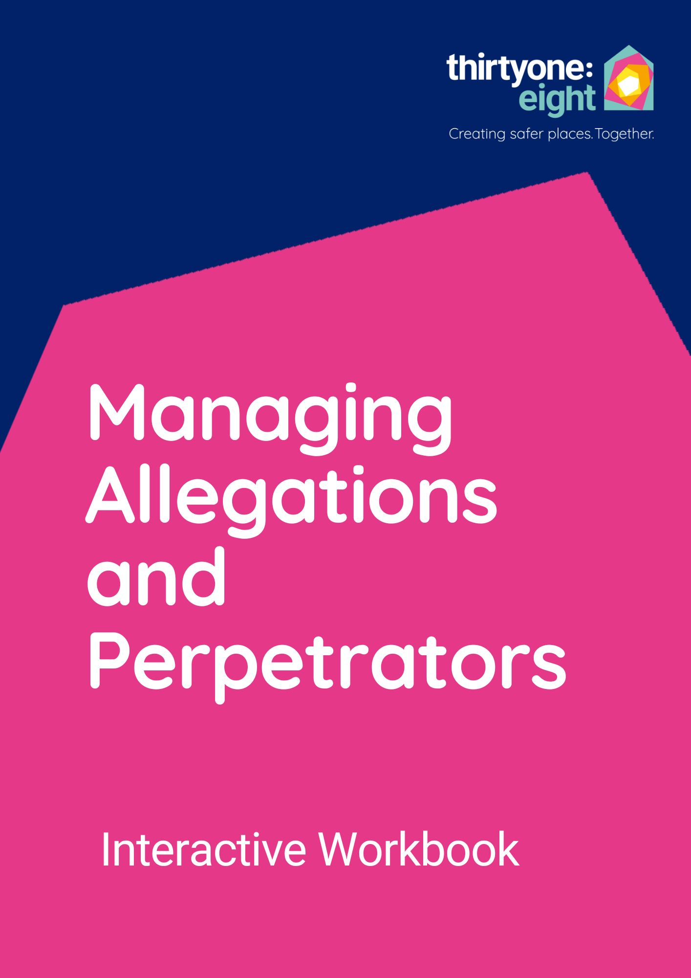


These workbook tasks supplement the course. They are primarily designed to enable you to apply your learning to a live situation, guiding you through the various steps needed to manage your situation safely. If you are not currently managing a live situation, or a particular task does not apply to your context, feel free to either leave it blank or use one of our hypothetical scenarios to respond to the questions.
Remember to save your work and store it securely, as you would any other safeguarding document.

Live safeguarding situations often unfold over time, so while this training can be done in one go, you can also revisit and update your answers.

Contents
Workbook Tasks: 5
Introduction 5
Task 1: 5
Module 1: Concern 5
Task 2: 5
Task 3: 6
Task 4: 7
Task 5: 8
a) Record keeping: 8
b) Confidentiality: 9
c) Liaise with statutory bodies: 9
d) Identify key people internally 10
Module 2: Collaboration 12
Task 6: 12
Task 7: 12
Task 8: Scenario – phone call: 13
Task 9: 15
Task 10: 18
Module 3: Contract 19
Task 11: 19
Task 12: Scenarios – Sam and Annie 21
Task 13: 25
Module 4: Consequences 26
Task 14: 26
Task 15: 29
Task 16: 29
Task 17: Scenarios continued 30
Task 18: 33
Module 5: Care and Community 34
Task 19: 34
Task 20: 35
Task 21: 35
Task 22: 36
Conclusion: 37

Workbook Tasks:

Introduction

Task 1:
One definition of abusive behaviour is:
Physical, verbal or psychological acts that violate an individual’s human and civil rights. Some abuse constitutes a criminal offence.
Can you think of examples of abusive behaviour?
If you are attending this training in response to a live situation, list the behaviours you are aware of that are causing concern.
Type your answer here:

Module 1: Concern

Task 2:
How did you become aware of the allegation or abusive behaviour in your live situation?
Was it through one, or more than one, of these ways, or something else? (Highlight / underline the relevant options)
- Recruitment process for a new volunteer or staff member.
- A criminal records check flagged a concern.
- A verbal disclosure from the victim-survivor, the perpetrator, or a third party.
- Known local information, or a report in the local papers or social media pages.
- You were informed by your denomination, area network or other umbrella body.
- You were contacted by statutory agencies – the police, probation, or social services.
- Someone in your organisation raised a concern.
- You heard a rumour or gossip.
- You became aware of someone being non-compliant with your code of conduct
- You noticed someone displaying behaviours that could put others, themselves and the organisation at risk of harm or accusations of abuse.

How might the way you became aware of the situation inform your next steps?
Type your answer here:

Task 3:
Turn to page 6 in your course handbook. Look at the table defining different legal statuses of abusive behaviour.
What is the legal status of the behaviour in your live situation?
How might this affect your next steps?
Type your answer here:

Task 4:
If your live situation is a recruitment process, consider the following questions:
- Is the known or suspected perpetrator applying for a role in your organisation?
- What is the nature of the role applied for?
- What are or were the circumstances of the offences?
- What is the background to the offences?
- Is there any other relevant information?
Type your answer here:

If your live situation is an allegation or self-disclosure about someone who already holds a role in your organisation, record and report this immediately and follow your safeguarding processes as set in your policy. Then consider these questions:
- What role (if any) does the person currently hold in your organisation?
- Who could be at risk from harm?
- What are or were the circumstances to the abusive behaviours?
- Is there any other relevant information?

Task 5:
Type your answer here:

For this task, identify your role and responsibilities for your live situation in terms of: a) record keeping, b) confidentiality, c) liaising with statutory agencies and d) identifying key people internally:

Record keeping:
Consider your live situation and answer the following: | (Y / N / N/A)
I have made a record and passed it to the Safeguarding Lead.
I am the Safeguarding Lead, and I have created a case file for this situation and stored it securely (physical or online location).
I am the Safeguarding Lead, and I am maintaining a running record of all new information, actions, emails, phone calls and decisions related to this situation.

Confidentiality:
Read appendix four in your course handbook before completing the following:
List the people in your community who you think need to know about your live situation, giving reasons why for each.
Do all of these people need to know all the details? Be specific about who needs to know what and why.
If you are ever unsure, seek advice (from our helpline, your umbrella body or statutory agencies) before giving potentially confidential information to someone else.
Name and role | What they need to know | Reason they need this information
Your answer here | Type your answer here | Type your answer here

Liaise with statutory bodies:
Which agencies do you need to contact / have you contacted?
Why / Why not?
If you don’t need to contact them at the moment, when would this change?

Agency | Already contacted? | Reason | Contact if…
Police | Type your answer here | Type your answer here | Type your answer here
Social Services
Local Authority departments responsible for allegations against those in Positions of Trust
Probation Services / Criminal Justice Social Workers
Barred Lists
Charity Regulator
Other (add name here)

Identify key people internally
What roles are required to support your live situation safely (trustees, leaders, pastoral supporters etc)?
Are there any conflicts of interest that mean the people in these roles may not be appropriate to involve in this particular situation?
How will you overcome this?
Role / Name | Conflict of interest? (Y/N) | If yes, how will you overcome this.
Type your answer here | Y / N | Type your answer here

Module 2: Collaboration

Task 6:
Take some time to explore the signposting section that starts on page 47 of your course handbook. It is organised by nation as some agencies are nation specific.
Are there non-statutory agencies listed here that could support your live situation?
Are you already collaborating with other local or national agencies?
Type your answer here:

Task 7:
In your live situation, who needs support and in what areas? Think broadly, consider the needs and challenges of everyone involved: victim-survivor(s), known or alleged perpetrator(s), support teams in your organisation, the families of those involved etc.
Begin to compile a ‘support directory’ of agencies who you can collaborate with or signpost to as your situation evolves. Highlight any you want to contact in the next few days.

Individual’s name | Area of support | Organisation / Agency name and details
Type your answer here | Type your answer here | Type your answer here

Task 8: Scenario – phone call:
The local Probation Office has called you and they have someone they're working with who would like to attend your church. There are risks associated with this person, and they've told you that there will need to be a risk assessment done and a behaviour contract in place in order for him to attend. They tell you that his crime was of a violent nature and that he is also on the Sex Offenders Register, and they want to know if your church is willing and able to accommodate this person's attendance, and can they meet with you to discuss this further. The person in question has given them permission to call you on their behalf and is willing to engage in any process needed.
- Who in your organisation might need to be made aware?
Type your answer here:

- What are your initial thoughts, and do you have any concerns?
- What further information do you need?
Type your answer here:

Task 9:
Think about the scenario questions in relation to your live situation.
- Who needs to be made aware of the situation so decisions can be made about how to manage it?
Name | Role | Reason for involvement
Type your answer here: | Type your answer here: | Type your answer here:

- What are your initial thoughts, and do you have any concerns?
Type your answer here:

- What questions do you need to ask about your live situation so decisions can be made about how to manage it? Who can answer them? (There are sample questions on the next page but we recommend making a note of your own questions before you look at these).
Type your answer here:

Sample Questions for Question 3 of Tasks 8 and 9:
- What level of risk does this person pose to the community?
- Who has been identified as most at risk (named individuals or a particular demographic)?
- How will Probation / Criminal Justice Social Work and other statutory agencies support your organisation going forward?
- What are the conditions of the person’s licence that we need to know?
- What is our responsibility if the individual breaches the agreement? And who do we inform? Would it be Police or Probation / Criminal Justice Social Work? Is there out of office hours support?
- What would the consequences be for the individual if they do this?
- What other supports are in place for them?
- Does the individual have a family or children? Will they be attending with them?
- What information do probation / criminal justice social work need from the us?
- What is the recommended time frame for contract/review?
- Will there be any follow up by probation once the individual starts attending?

Task 10:
Reflect honestly on the following questions:
- Are there any aspects of your live situation that you don’t feel your organisation is equipped to manage?
- What are the implications of this?
- Who do you need to talk to about it?
Type your answer here:

Module 3: Contract

Task 11:
Consider your live situation and answer the questions below. You can write your answers as notes here, use your organisation’s own risk assessment proforma, or print the risk assessment template on page 33 of your course handbook. Thirtyone:eight members can download an editable version of the template from the Resources Library by searching ‘Behaviour Risk Assessment Template’. Some of the tasks you have already completed will help you with this.

- What are the abusive behaviours or concerns?
Type your answer here:

- What are the possible risks?
Type your answer here:

- Who is at risk?
Type your answer here:

- Can the risks be managed?
Type your answer here:

Task 12: Scenarios – Sam and Annie
Consider either Sam or Annie’s situation (or both) and answer the risk assessment questions using the boxes below or a risk assessment template. There are sample risk assessments for both Sam and Annie starting on page 19 of your course handbook. However, we recommend attempting this task yourself before you refer to these.
Sam:
A local probation officer called you asking if you might be willing to support an ex-offender. Your church has considered this and feel that they could offer support and agree to attend a meeting to discuss this further.
Having met with Sam and his probation officer you learn the following additional information: Sam was convicted for rape and murder of his ex-girlfriend 20 years ago. He served 16 years in prison, and it was through the prison chaplaincy that he became a Christian. He is not in a relationship currently.
He is on the Sex Offenders register for life and has very specific conditions that he must adhere to, the ones thought relevant for the church to know are: he is not to be alone with any females, any relationships with opposite sex have to be declared, any breach of the behaviour contract must be reported, he is to be escorted while on church premises or at church events, he is not allowed alcohol or drugs.
He is also required to regularly check in with probation and the local mental health services, as well as complete some courses with probation on anger management, drugs and alcohol and a domestic abuse programme.
- What are the abusive behaviours or concerns?
Type your answer here:

- What are the risks?
Type your answer here:

- Who is at risk (remember to think broadly)
Type your answer here:

- What can be done to manage the risks?
Type your answer here:

Annie:
You took up the post of Safeguarding Lead in your charity 6 months ago. You are aware of the importance of the safer recruitment process so are retrospectively doing criminal record checks for all volunteers. Annie has not previously been checked, and you cannot find any records relating to her volunteering role in the charity.
Annie is in her early 70’s and loves children. She helps out with the weekly parents and tots’ group. The project lead tells you that Annie “has been doing this for years, for as long as I can remember!” “She is a wee treasure; we would be lost without her!”
Annie wants to talk to you before you do the check. She discloses through the self-declaration form that several decades ago she sexually abused two teenage boys, and she thinks they might have gone to the police at the time. She was never charged or convicted and thinks ‘the past should stay in the past’ and that she’s not the same person now.
- What are the abusive behaviours or concerns?
Type your answer here:

- What are the risks?
Type your answer here:

- Who is at risk (remember to think broadly)
Type your answer here:

- What can be done to manage the risks?
Type your answer here:

Important note if you are working in Scotland: From 1st April 2025, the Disclosure (Scotland) Act 2020 makes it a legal requirement for those in a regulated role to be a PVG scheme member. It is also an offence to recruit someone to a role working with vulnerable groups without first confirming that they are an appropriate PVG scheme member. For more information see: The Disclosure (Scotland) Act 2020 - Volunteer Scotland
Throughout the UK: We have a duty to refer to the relevant barred lists when we have particular concerns that a person may not be safe to work with vulnerable groups. In Scotland, these lists are held by Disclosure Scotland. In England, Wales and Northern Ireland these lists are held by the Disclosure and Barring Service.
Follow the links below to find out if you would need to refer Annie’s situation to the lists. Use this opportunity to do the same for your live situation if you have one:
Making barring referrals to the DBS - GOV.UK
Making a referral to Disclosure Scotland - mygov.scot

Task 13:
What clauses would you want to include in either Sam or Annie’s contract, or the contract of someone in your live situation?
There are extensive examples of written agreement clauses in Appendix 3 of your course handbook, but we recommend creating a few of your own before you look at these. You may wish to share this resource and complete this exercise with other key people if you are creating a contract for a live situation.
Type your answer here:

Module 4: Consequences

Task 14:
Reflect on the following questions in the context of your live situation:
Is there already a safeguarding agreement / behaviour contract in place for the situation that has brought you to training?
Type your answer here:

If so, are the consequences for non-compliance clearly communicated?
Type your answer here:

Is everyone involved in monitoring the contract aware of them?
Type your answer here:

Is the person at the centre of the contract aware of them?
Type your answer here:

How have you clarified their understanding and agreement?
Type your answer here:

Do you need to inform anyone externally if a contract is breached? Who / when / how?
Type your answer here:

If there is not yet a contract in place, what consequences could / should be included? Why?
Type your answer here:

Are you comfortable enacting the consequences of the contract? Why / Why not? Who can you talk to about this?
Type your answer here:

If a contract has been in place for a long time, are the consequences still appropriate and upheld by all involved? If not, what action do you need to take?
Type your answer here:

Task 15:
If you are working with a perpetrator who has received a prison sentence, take a moment to read Appendix 7 in your course handbook now. Do you need to add any details to their contract as a result of their sentence type?
Type your answer here:

Task 16:
If your live situation is causing any tension or conflict in your community, take a moment to read Appendix 5 in your course handbook now. Make notes and share ideas with others in your group as appropriate.
Type your answer here:

Task 17: Scenarios continued
Consider the next parts of Sam and / or Annie’s scenarios and make notes on the following questions: 1. What are your concerns? 2. Who do you need to inform? 3. What consequences do you think there should be in this situation?
Sam:
Sam has been regularly attending church, and he has been compliant with the behaviour contract that has been put in place in the initial days of his attendance, but it's been three weeks since Sam has attended the services at your church, and he has not responded to any of the pastoral care messages that have been sent to him. It's been reported to you that Sam has been seen on several occasions at another local church with a woman, and they have been seen holding hands. This information has come from a trusted source, we've got no reason to question the information that we've got.
- What are your concerns?
Type your answer here:

- Who do you need to inform?
Type your answer here:

- What consequences do you think there should be in this situation?
Type your answer here:

Annie:
Annie has decided that she would like to continue to volunteer with your charity. A risk assessment has been done, and a behaviour contract has been discussed with Annie, and she can no longer pop in to see people that she has met through the charity. Annie has reluctantly agreed to this and signed the contract. You get chatting to Vicky, who attends the parent and tots’ group, and she tells you what a help Annie has been and how glad she is that she's back. Vicky shares that she was really struggling to manage with having a newborn baby and a three-year-old toddler, and she couldn't get out to do her shopping sometimes, and with a teenage boy to feed as well, she was always running out of food. She tells you that when she was talking to Annie about this one day, Annie offered to pop into the shops and drop around any shopping she needed. You find out that this has actually been going on for a few weeks. When asked about this, Annie thinks that you're overreacting and says that it was just for a wee while until Vicky got on her feet, and that there was no harm done.
- What are your concerns?
Type your answer here:

- Who do you need to inform?
Type your answer here:

- What consequences do you think there should be in this situation?
Type your answer here:

Task 18:
Reflect on how Sam and Annie’s scenarios might relate to your live situation.
Make notes on any learning points or actions to share with your team.
Type your answer here:

Module 5: Care and Community

Task 19:
If Annie or Sam attended your church or community group, who would be suitable people to support them?
Type your answer here:

Can you think of times where that community support element has been beneficial to individuals in your communities? If so, who was involved and how?
Type your answer here:

How might community support bring benefits in your live situation?
Type your answer here:

Task 20:
Explore the following links to see how these models and organisations can support your live situation. Make notes and discuss with other members of your group:
Circles UK – Circles of Support and Accountability
The Good Lives Model of Offender Rehabilitation
Recycling Lives Charity
Unlock
Type your answer here:

Task 21:
Reflect on what support you are receiving in relation to your role in your live situation:
Question | Yes / No / N/A
Do you have someone you can talk to about questions and concerns?
Do you meet regularly with someone who supports you?
Have you received sufficient training and information to fulfil your role?
Do you feel equipped and comfortable with all aspects of your role?

If the answer to any of these questions is no, who can you talk to about this?
Type your answer here:

Is there any further support, information and training you would like?
Type your answer here:

Task 22:
In what ways is your organisation already well placed to receive individuals who have acted, or are suspected of acting, in abusive ways?
Type your answer here:

If you are attending this training with a live situation in mind, what is working well for you so far?
Type your answer here:

Conclusion:
As you come to the end of this training, look back through this workbook and highlight anything that you particularly want to remember or actions you need to take forward.
Share these actions and reflections with other members of your team as appropriate.
What good practice have you learned about or been reminded of that you would want to add to your policies for future situations?
Type your answer here:

If you have questions about how to proceed with your particular situation, our helpline advisors are there to help you: helpline@thirtyoneeight.org or 03030031111 option 2.
If you’re calling from outside of the UK, you can reach the helpline on: (+44) 01322 517817

Guidance on Developing and Implementing Multi-agency Policies and Procedures to Protect Vulnerable Adults from Abuse

